St. Francis Institute of Technology, Mumbai - 400103

**Department Of Information Technology**

A.Y. 2024-2025

Class: TE-ITA, Semester: VI

Subject: **Web Lab**

**Experiment – 1: To study web analytics using open source tools like Matomo, Open Web Analytics, AWStats, Countly, Plausible.**

1. **Aim:** To study open source Web Analytics tools
2. **Objectives:** Aim of this experiment is that, the students will be able

* To Understand open source tools for web analytics in web apps development and deployment 

1. **Outcomes:** After study of this experiment, the students will be able

* To understand the importance of web analytics.
* Learn about various open source tools for web analytics.
* To have an introduction to web semantics

1. **Prerequisite:** Knowledge of digital web evolution,
2. **Requirements:** Personal Computer, Windows operating system, browser, Internet Connection, google doc.
3. **Pre-Experiment Exercise:**

**Brief Theory:** Refer shared material

1. **Laboratory Exercise**
   * + 1. **Procedure:**

**a. Answer the following:**

* + Define web and compare with term Internet.
  + What is a Web based application?
  + Compare Google analytics with Countly, Plausible, Matomo.

| Sr No | Parameter | Google Analytics | Countly | Plausible | Matomo |
| --- | --- | --- | --- | --- | --- |
|  | Session | Advanced session tracking | Focus on app sessions | Simplified session tracking | Advanced with cookie-less option |
|  | Total Visitors | Unique IDs via cookies | Device and platform tracking | Privacy-friendly counting | Flexible (cookie or cookie-less) |
|  | Returning Users/Visitors | Cookie-based, detailed breakdowns | Device or login-based tracking | Privacy-focused, simplified | Flexible tracking |
|  | Average Request Received | Comprehensive | API calls and events tracked | Simplified metrics | Detailed with custom reporting |
|  | Time Spent | Page and session durations | Focus on app active time | Simplified time-on-page | Comprehensive tracking |

**b**. **Attach screenshots:**

* Web Evolution
* Google Analytics home page
* Matomo user interface

1. **Post-Experiments Exercise**
2. **Extended Theory:**

Nil

1. **Questions:**

* Write in tabular form main characteristics of each Web generations (web theme, technologies, level of functionalities, key differences)
* Add new feature to Matoma tool take SS and attach
* Give important KPI of web analytics.

1. **Conclusion:**

* Write what was performed in the experiment.
* Write the significance of the topic studied in the experiment.

1. **References:**
2. <https://aircconline.com/ijaia/V8N6/8617ijaia02.pdf>
3. <https://support.count.ly/hc/en-us>
4. <https://analytics.google.com/analytics/web/provision/#/provision>
5. **Laboratory Exercise:**
6. **Define web and compare with term Internet.**

**Ans:**

**WEB:** The Web (World Wide Web) is a system of interlinked hypertext documents and resources accessed through the Internet using web browsers. It allows users to navigate and interact with websites, applications, and multimedia content via protocols like HTTP and HTTPS. It is a service that relies on the Internet infrastructure to function.

**INTERNET:** The Internet is a vast global network of interconnected computers and servers that enables communication and data exchange using standardized protocols like TCP/IP. It provides the foundation for various services, including the Web, email, file transfer, streaming, and more.

| **WEB** | **INTERNET** |
| --- | --- |
| A collection of websites and web services. | The global network that connects devices. |
| To deliver content and services through HTTP. | To enable communication and data exchange. |
| Operates on the Internet infrastructure. | Functions independently of the Web. |

1. **What is a Web based application?**

A web-based application is a software application that runs on a web server and is accessed through a web browser over the Internet or an intranet. Unlike traditional desktop applications, web-based applications do not require installation on the user's device.

### Key Features of Web-Based Applications:

1. Accessibility: Accessible from any device with a web browser and an Internet connection.
2. Cross-Platform Compatibility: Works on various operating systems (Windows, macOS, Linux, etc.) without requiring platform-specific installation.
3. Centralized Updates: Updates and maintenance are performed on the server, ensuring all users access the latest version without needing manual updates.
4. Examples: Gmail, Google Docs, Amazon, and Netflix.

Web-based applications are widely used for their scalability, cost-efficiency, and ability to provide real-time interactions across devices and platforms.

**B.** **Attach screenshots:**

1. **Web Evolution**

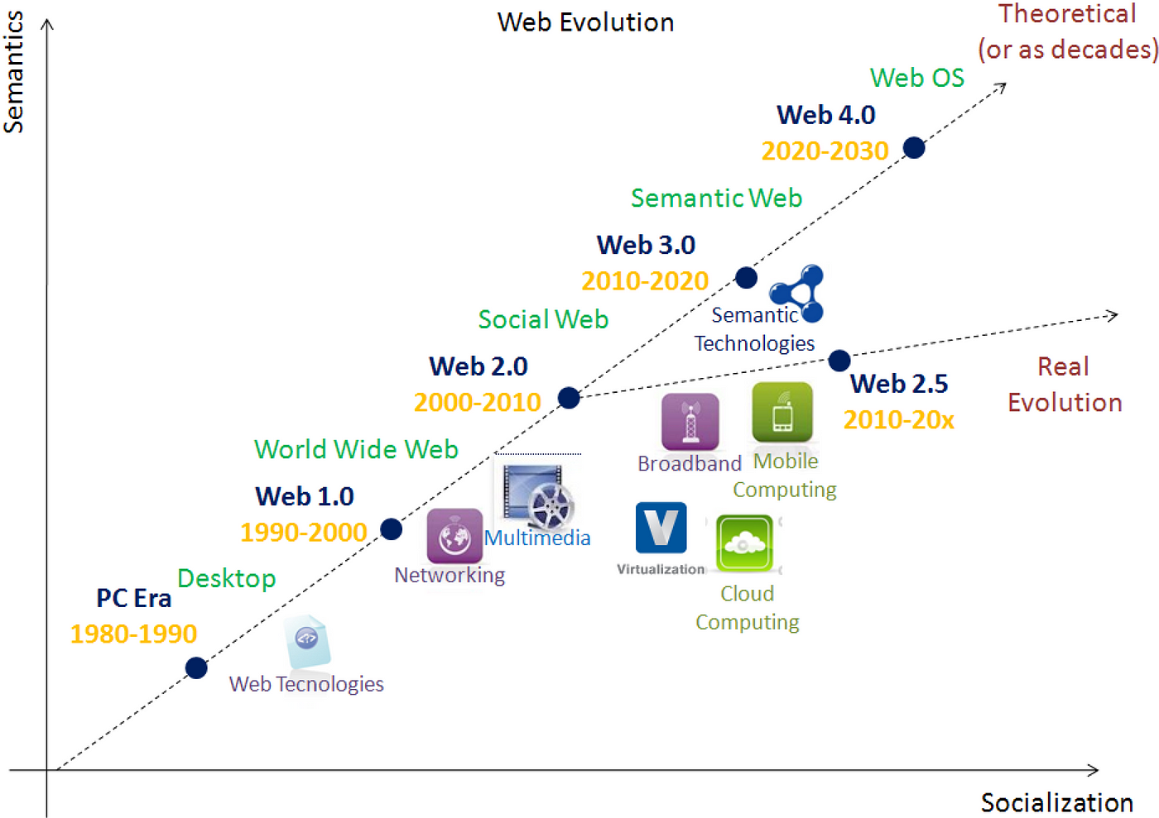

The World Wide Web has evolved through several stages, each characterized by new technologies and user interactions. These stages are often referred to as Web 1.0, Web 2.0, Web 3.0, and Web 4.0.

1. **Google Analytics home page**

Creation of an account:

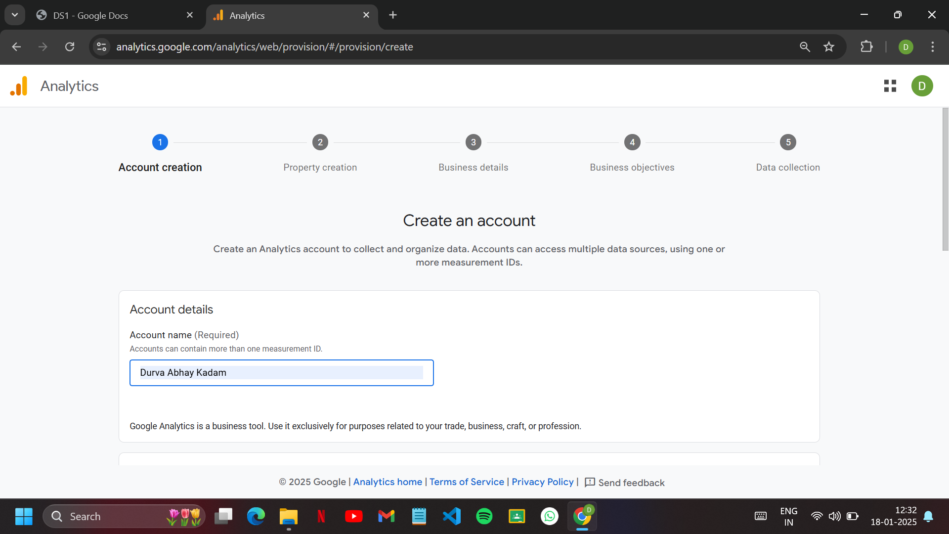

Property Details: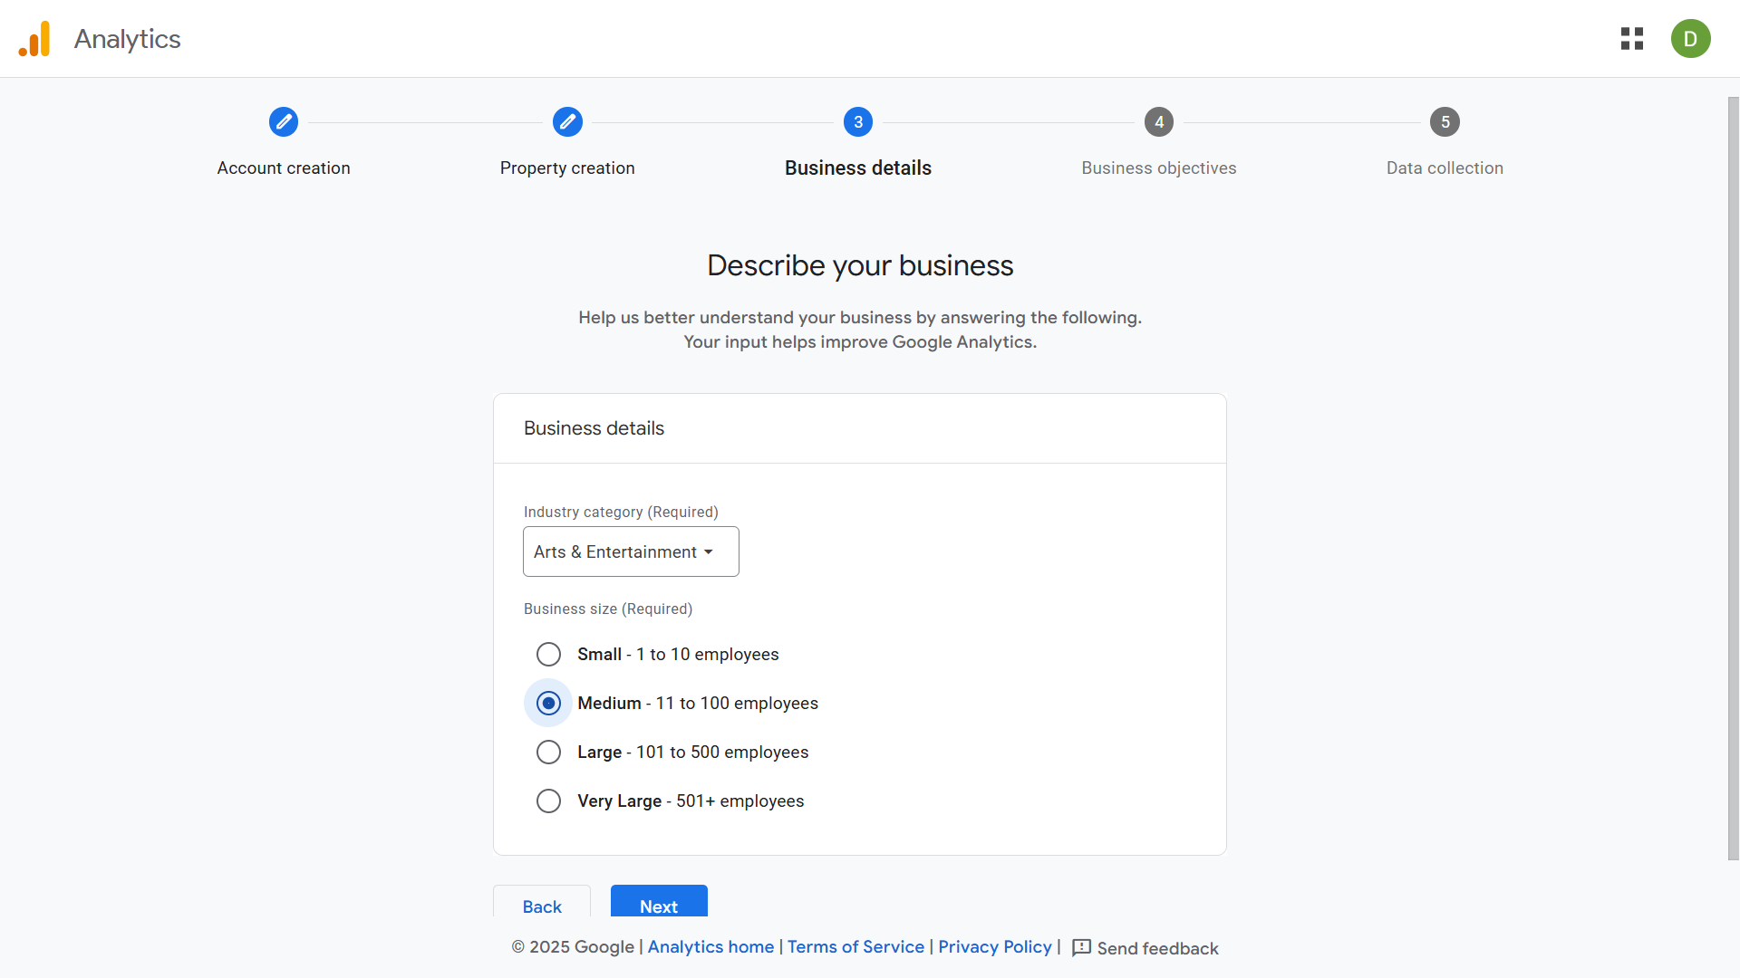

Business Details:

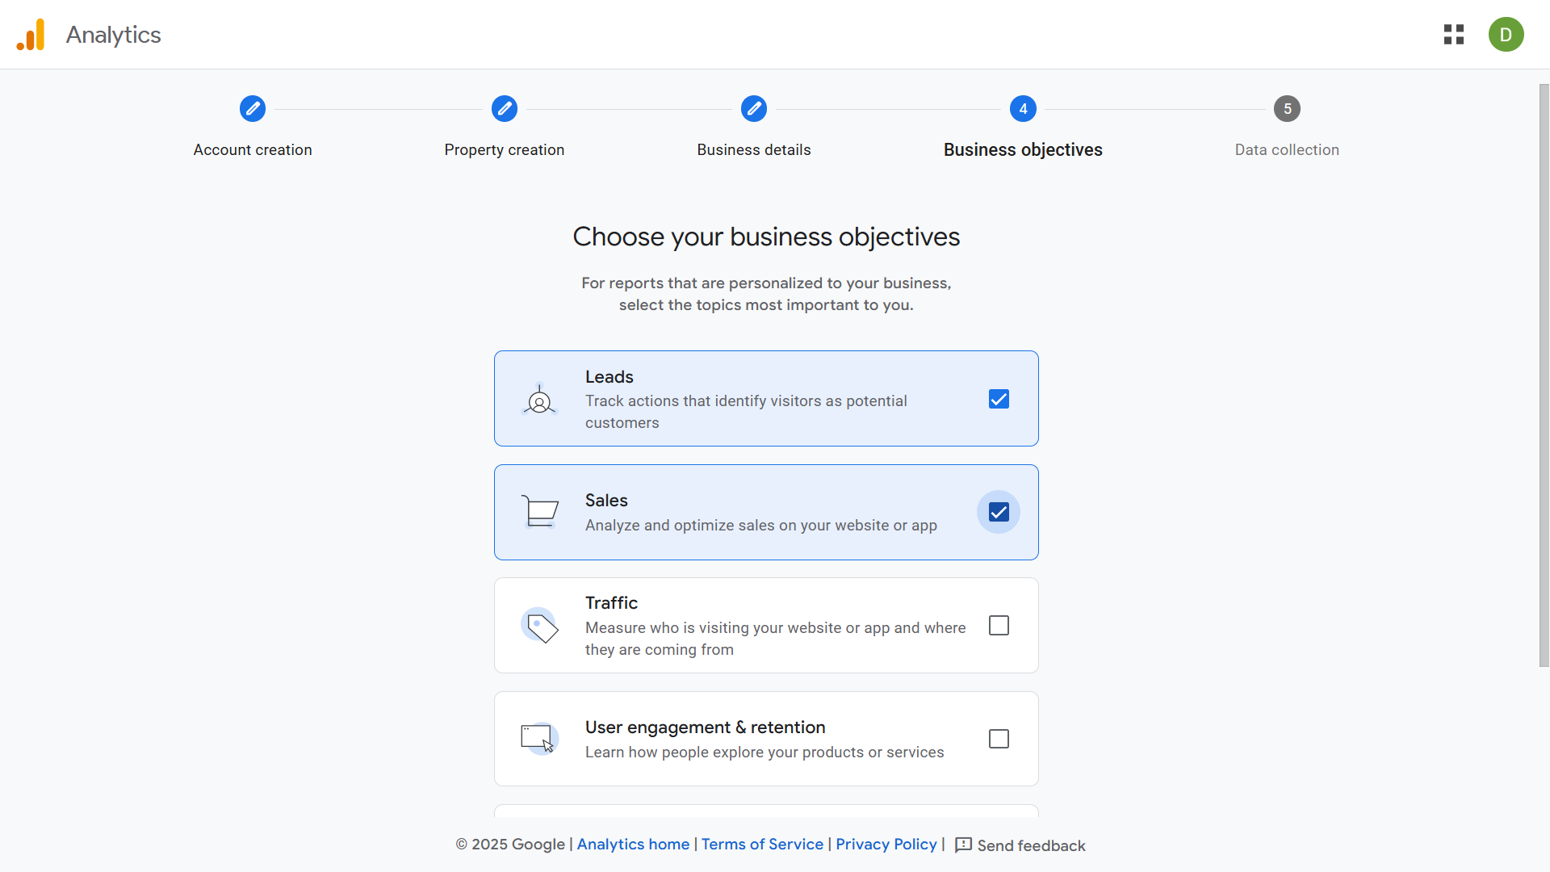

Data Collection: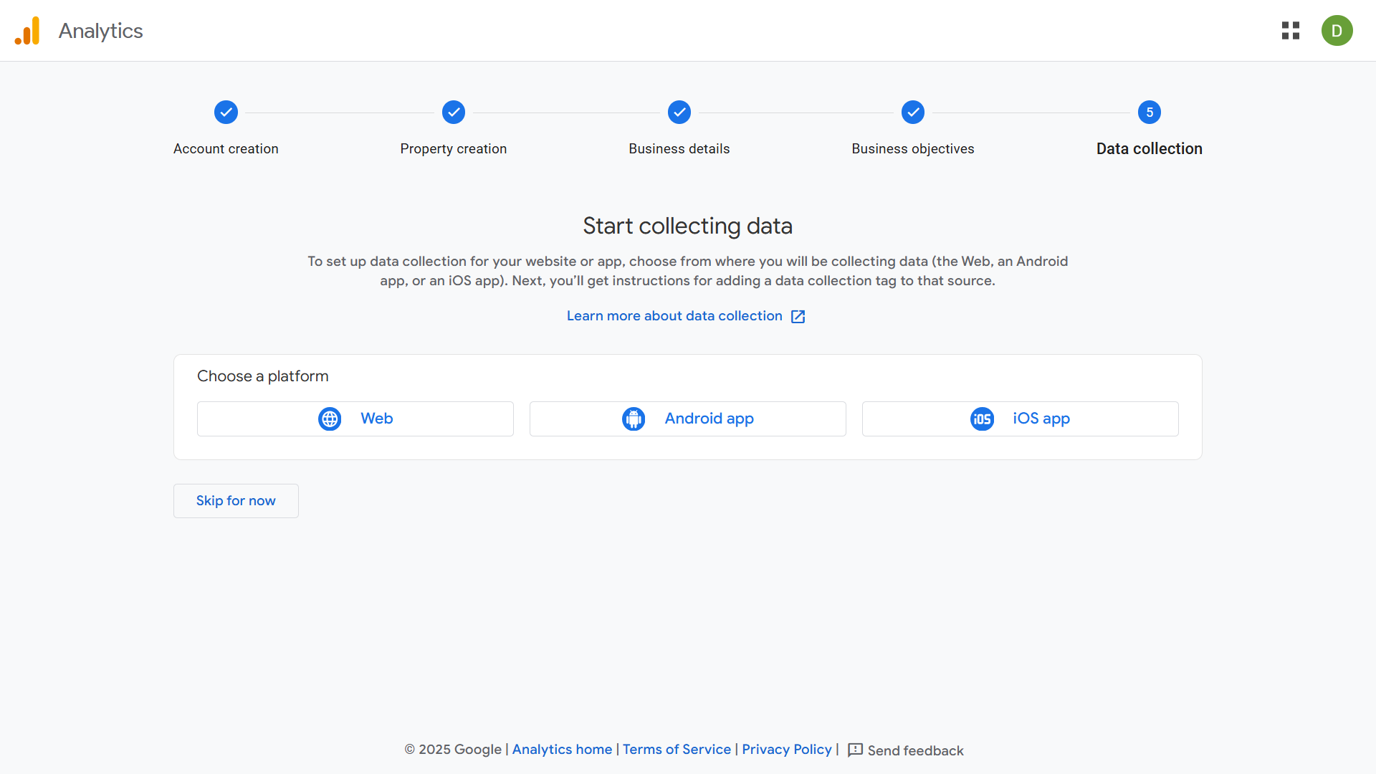

1. **Matomo user interface**

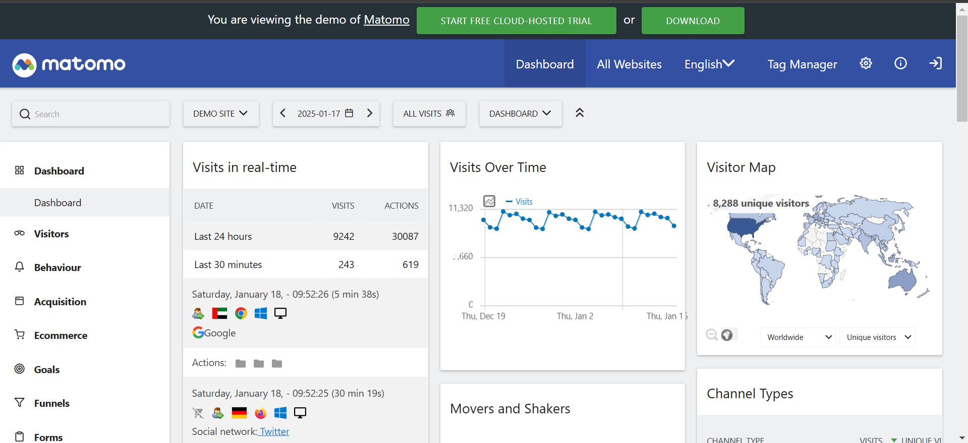

The Matomo UI is clean and structured, offering intuitive navigation through its left-hand sidebar and detailed analytics in the central panel.

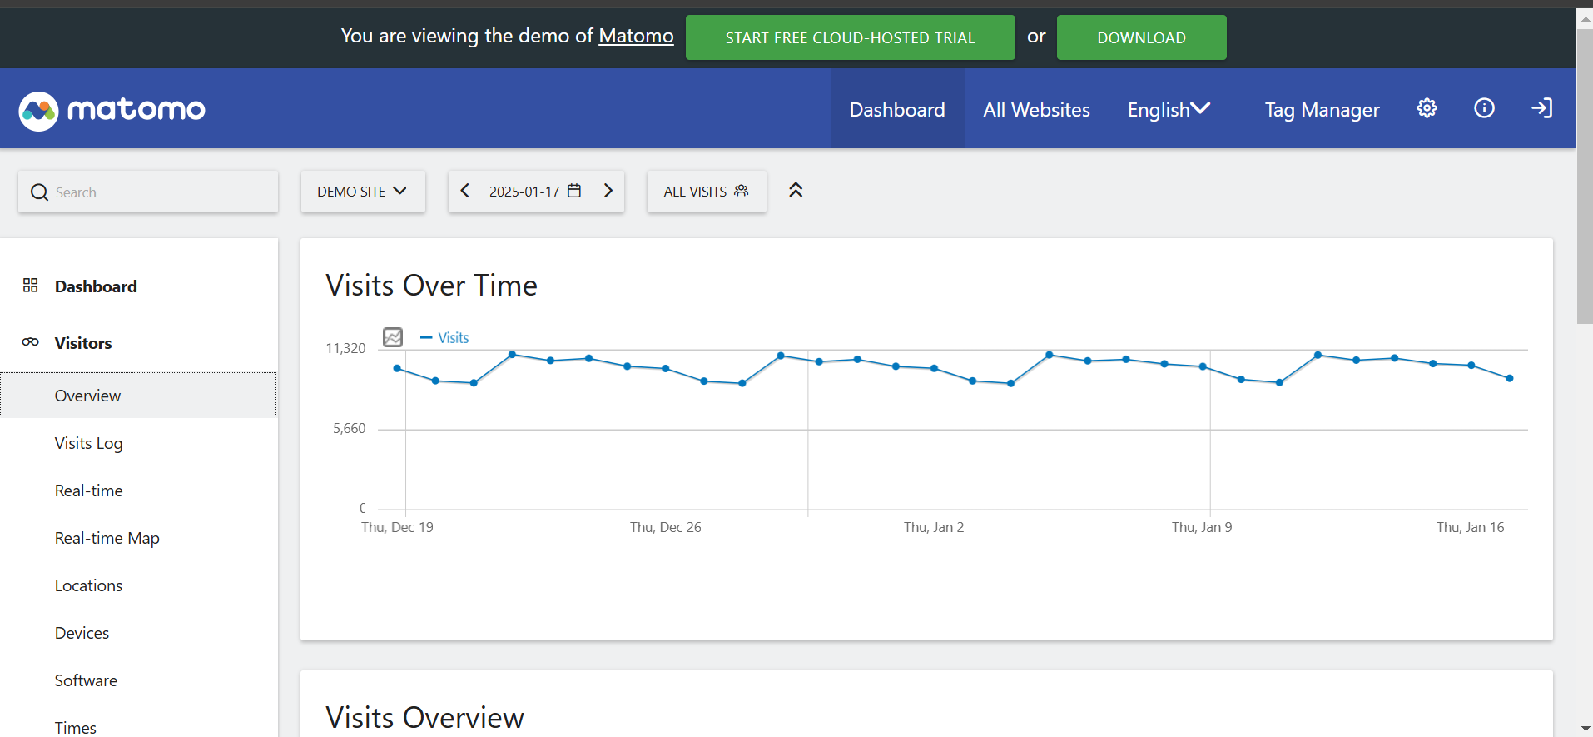

The "Visitors Overview" graph in the Matomo UI provides a clear visual representation of visitor trends over time. It effectively highlights fluctuations, but adding interactive elements like tooltips etc.